
WHAT IS A “MODULAR” HOME?
(B03)042009
IT IS NOT : A MOBILE HOME,
AN INFERIOR QUALITY HOME,
RESTRICTED TO BASIC PLANS OR STYLES,
RESTRICTED TO SMALLER, LOW COST HOMES,
RESTRICTED BY ZONING,
DIFFICULT TO FINANCE,
A NEGATIVE AT TIME OF RE-SALE,
HERMETICALLY SEALED TO ARRIVE ON SITE READY TO MOVE INTO.

IT IS A “STICK BUILT” HOME, CONSTRUCTED IN A FACTORY UNDER “IDEAL” CONDITIONS, STRUCTURALLY ENGINEERED TO BE BUILT IN SECTIONS (MODULES) WHICH CAN BE TRANSPORTED TO YOUR SITE. The modular concept is to FACTORY produce a product in order to minimize ON-SITE work. Since the modular cannot replace all of the on site work 100%, we combine the best of both methods to achieve the best possible product structurally and esthetically, for the lowest cost and in the least amount of time.

Some of the reasons for the benefits derived from Modular Construction, include:
- Use of KILN dried lumber, nailed and glued, on site construction cannot use this quality material or method,
- “GREEN” construction and elimination of unhealthy mold and mildew in your house,
- Under roof storage of materials to protect them from the elements before your house is built,
- Precise measuring and cutting of materials on pre-set equipment and jigs,
- Work performed in a controlled environment, no snow, rain, ice, mud, etc. to hamper the workers or the affect the quality of the product,
- Continuous in-house inspections PLUS third party inspections to ensure the quality and integrity of your home,
- Accurate in house engineering and drawings detailing virtually every stud and joist,
- Reverse some “on-site” construction sequences, resulting in a better quality product,
- Components (Modules) each structurally strong enough to retain its integrity without the remaining components,
- Floor joists built into the center beam, not standing on edge on top of the beam,
- Steel strapping used in critical areas to add strength. Our homes easily meet the 100+ MPH wind requirements,
- Two story homes are built with independent ceiling and upper level floor systems resulting in a stronger and more silent home,
- Your option to act as your own coordinator to complete the final limited phases of completing your home, thus saving substantially on labor,
- Applicable for residential and commercial projects of all types,
- Accurate costing !
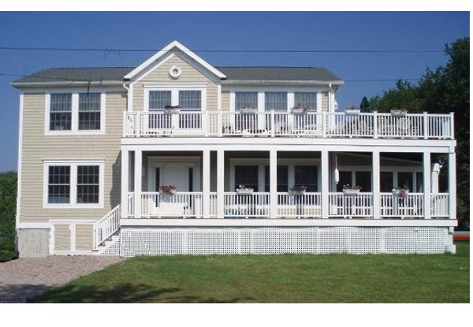
HALLMARK HOMES, INC.

